WILD JACKS:

CARD GOBANG

An amazing Classic board & card game to play online/offline with your friends.

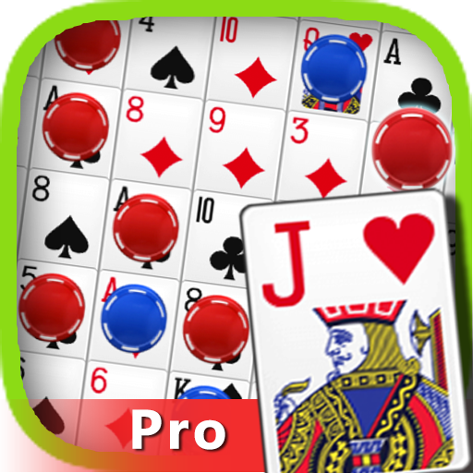

Game Overview

Game Concept

This is free online multiplayer board game that supports up to 3 players and is specially designed to play with family and friends.

Genre

Online/Offline, Single Player, Multiplayer, Card Game

Target Audience

Anyone who is Fun loving and wants to challenge his loved ones to a light and interesting game.

Game Flow Summary

This is a card and board-based game where the player who is successful in forming two sequences of 4-5 tokens will be the winner.

Each player will get chances alternatively to form a sequence.

Look and Feel

* HD Graphics
* Smooth Animation
* Online Mode (Play with your friends even if they are to another side of the globe)
* Offline Mode (Play in single device with your friends)
* Single Player (Play against 1-2 bots in offline mode)
* 4 Players mode (2 vs 2)
* Random Player mode (Play with random players across the globe online)
* Leader Board

Gameplay and Mechanics

Gameplay

* At the start of the game each player gets 5 cards randomly.  
  The Game always begins with the PLAYER1 and move in a clockwise direction.
* You select a card of your choice from the cards given to you.
* Place one of your poker chips on the matching card on sequence board.
* You can change your selection cards any time before placing chip on board.
* Finally, you draw a new card from the draw deck.
* As your selected card is placed on the game board then your used card will be placed beside you (i.e., near P1) and that is visible to everyone.
* TO WIN THIS GAME: The first player that scores two Sequences wins the game.

Please note that you may use any one of the spaces from your first Sequence as part of your second Sequence.

Mechanics

* Objectives - One Player must score SEQUENCES before their opponents. A sequence is a connected series of five of the same color chips in a straight line, either up and down, across or diagonally on the playing board.
* How to Play – At the start of the game each player gets 5 Cards randomly. The game always begins with the PLAYER1 and move in the clockwise direction.
* Your Turn – You select a card of your choice from your hand (tapping). Then place one of your chips on the matching card on the game board (tapping). Finally, you draw new card from the draw deck. A card once selected cant be undone. As your selected card is placed on the game board then your used card will be placed beside you (i.e., near P1) and that is visible to everyone.
* The Game Board – Each card is pictured twice on the game board, with the exception of the Jacks. A player can play on either one of the card spaces as long as it is not already covered by another chip.
* The Bonus Card – The printed cards in the four corners of the game board are Bonus Cards. All players must use them as though their color chip is in the corner. When using a corner, only four of your chips are needed to complete a Sequence.
* The Crazy Jacks – There are 8 jacks in the card deck, some with Two eyes, other with one eye.

The Jacks with TWO EYES are wild. To play a two-eyed   
Jack, select the Two-Eyed Jack and place one of your chips on any card which doesn’t have any chip on it.

The Jacks with ONE EYE are not wild. To use a one-eyed jack, click on the one eye card and then tap on any of the opponent’s chip to remove it.

REMEMBER, removing an opponent’s chip would cost one chance meaning the player would not be able to put his own chip after using one eyed Jack.

* Swapping Card – If you hold a card which doesn’t have an open space on the game board i.e., both spaces on board have chips on them, then you are holding a dead card and thus it can be replaced (swapped) with a new card.

**Note***: Sequence Game has many alternatives and so it is called by many names….*

*The gameplays of those alternatives may vary.*

*A MAJOR DIFFERENCE could be the use of Bonus Cards on each corner of the board because in some alternatives they can act as an individual CARD for everyone and so the player will have to form a sequence using the BONUS CARD cum only three other cards if he tries to form one considering the bonus cards as a TOKEN. One example where it occurs is, SEQUENCE.*

INTERFACE

The game has a very user-friendly interface which makes it easy for users of each age groups to be able to start and play the game without any extra efforts.

* The game starts with the MENU scene consisting of 7 (3 large + 4 small) buttons. The 3 large buttons are: Vs computer, Play Online, With Friends. The 4 small buttons are: Sound On/Off toggle, Leaderboard, How to Play, Rate It.
* Clicking each of the large buttons would open a pop up which would allow the player to customize the game according to their requirements like: number of sequences to win, Map, Game Mode, Hint Card toggle.

And thus, the user can tap PLAY and start playing.

* The Main game consists of all the required game objects and a HUD at the top of the screen containing A timer (for each player’s turn and a SETTINGS button).
* By tapping on the SETTINGS button, user can gain access to HINT card and SOUND settings. He also is provided with an option Button for GAME RULES where he can check all the necessary Game rules.

He can also END the Game when he needs with the cost of his defeat and return to the MAIN MENU.

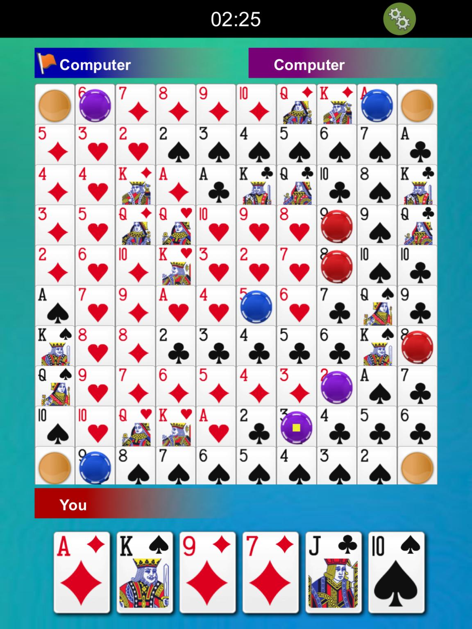

HARDWARE (TARGET)

Any Android/iOS Phone with a minimum of 1 GB of RAM will be able to run the game

A stable Internet connection is required in order to play the game with your friends or other players ONLINE.

SOFTWARE

THE GAME IS BASED on UNITY 2018.1.23f.